River Habitat Survey and Trout Habitat Score with mobile application

# Instructions for use

# The River Habitat Survey is much simplified if a digital form is used instead of paper. (If paper is used, more than 100 pages will be needed for each river). Field work is much faster and there will be no error in transforming the data to a computer. Digital forms have been created for the River Habitat Survey and for Trout Habitat Score.

# The principle is to upload an Excel file with a code for the form to a web platform. There the form is created and data can be filled in in a webform using a phone or a tablet. The data is automatically saved on the device and uploaded to your account on the web platform when there is internet access. After each river reach or electrofishing site, the form is saved and can be exported to an Excel file.

# Files for the digital forms:

# The files that are needed to create the digital forms are available at [www.Retrout.org/](http://www.Retrout.org/)River Habitat Survey or from [hakan.haggstrom@lansstyrelsen.se](mailto:hakan.haggstrom@lansstyrelsen.se).

# XLSform Protocol A Waterbiotope.xlsx

# XLSform Protocol D Migration Barriers.xlsx

# XLSform Trout Habitat Score.xlsx

# Download these files.

# Create an account for storing data

# You need to set up an account where your data can be stored and managed. There are several on-line services available, e.g. [www.ONA.io](http://www.ONA.io) or [www.kobotoolbox.org](http://www.kobotoolbox.org). The forms hav been tested and confirmed to work for Ona, but below is also a description for KoBo Toolbox. Ona has a limitation of 500 uploads per month for the free-ware. KoBo Toolbox have no limitation. Both services have apps for Android, but not for iPhone/iPad. However, both services have webforms that work for PCs, Android- and iOS-devices. (The webforms are created by the service [Enketo).](https://enketo.org/)

# Create an account and upload the forms by following any of the instructions below.

# KoBo Toolbox

# Create an account at <http://www.kobotoolbox.org/>by selecting the right choice (Researchers, Aid Workers & Everyone Else) a bit down on the page.

# Fill in the form, click “Create Account” and verify your account by clicking the link which is sent to your e-mail address.

# Click “New” and then “Upload an XLSForm”. Choose one of the files you downloaded from Retrout.org. The form is created.

# Click on “Deploy” to start using the form.

# Ona

# Create an account at [www.ona.io](http://www.ona.io/)

# Log in and click on the project that is created in your account

# Click on “Add a form”

# Choose a file to upload. The form is created.

# Click on “Activate”.

# If you save a link to the form on the home screen of your device. You only need to have access to the internet when you open the form for the first time. You can then access the webform offline. The filled in forms are saved locally on your device and uploaded when there is internet access.

# Collecting data

KoBoToolbox

1. Log in to your account on the device you will be using for the data collection.
2. Click on the form in the list of forms

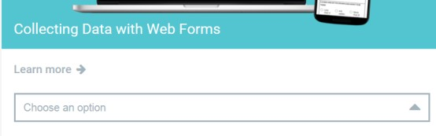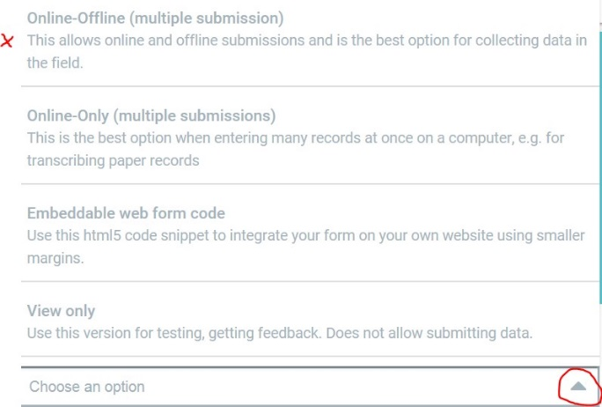

1. Chose Online-Offline under ”Collecting Data with Web Forms”
2. Click “Open”

Ona

1. 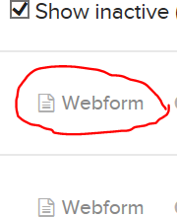Click on webform in the list with forms
2. The form is opened
3. Click on the symbol to the left to show forms in que or to force uploading (uploading is done automatically every 5 minutes)

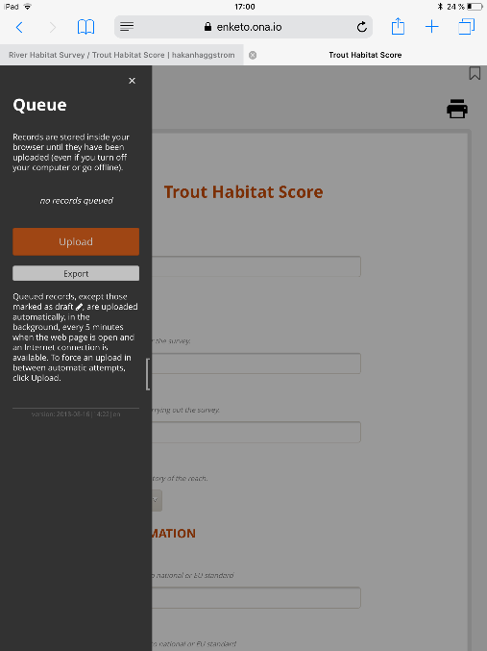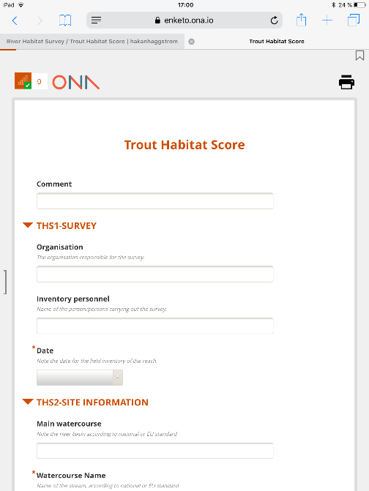

Export data from the application

Collected data may be exported from the Ona or KoBo databases in several different formats, eg Excel or *.csv (comma separated).

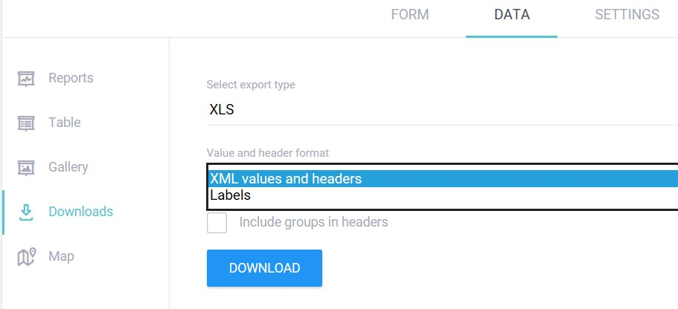KoBoToolbox

1. Click on the form and choose DATA and then “Downloads” to export
2. Choose “XML values and headers” to get data in the right format

Ona

1. Click on the form to open the overview
2. Click “Prepare Export” and choose format

